EXPERIMENT NO. 10
Student Information System using Zoho Creator (SaaS)

Aim
To develop a cloud-based Student Information System using Zoho Creator to store, manage and display student information and demonstrate the Software as a Service (SaaS) cloud model.

Objective
• Create a cloud application to maintain student records.
• Store student personal and academic details.
• Generate reports and display individual student information.
• Demonstrate SaaS using Zoho Creator.

Software Requirements
• Zoho Creator
• Google Chrome
• Internet Connection
• Deluge Script (optional)

Theory
The Student Information System is a cloud-based application developed using Zoho Creator. It stores student details such as name, register number, address, phone number, age, course, grades, attendance percentage, progress report and semester marks. All information is stored securely in the cloud and can be accessed through reports, demonstrating the SaaS model.

Fields Used
Student Name, Register Number, Address, Phone Number, Age, Course, Grade, Attendance Percentage, Progress Report and Semester Marks.

Algorithm
1. Start.
2. Open the Student Information System form.
3. Enter student personal details.
4. Enter academic details.
5. Save the record.
6. Generate report.
7. Display individual student record.
8. Stop.

Procedure
1. Login to Zoho Creator.
2. Create a new Student Information System application.
3. Add all required fields in the form.
4. Save the form.
5. Enter sample student records.
6. Create a report to display all records.
7. Verify the stored data.

Observation
The application accepted student information successfully. Records were stored in the cloud database. The report displayed all student records, and the individual record view showed complete student information. The SaaS application functioned correctly.

Result
The cloud-based Student Information System was successfully developed and executed using Zoho Creator. Student records were stored and retrieved successfully.

Conclusion
The experiment successfully demonstrated a SaaS-based Student Information System using Zoho Creator for maintaining student information.

Screenshots
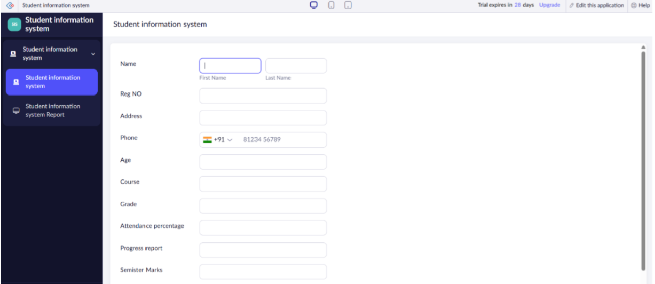
Figure 1: Student Information Entry Form
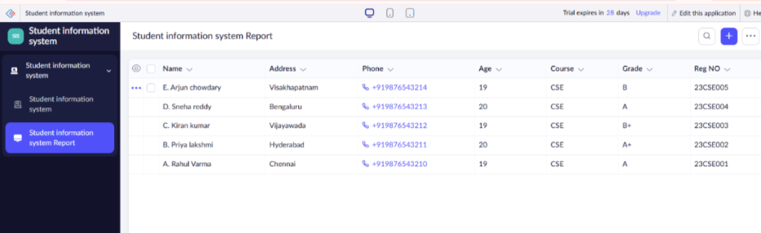
Figure 2: Student Information Report
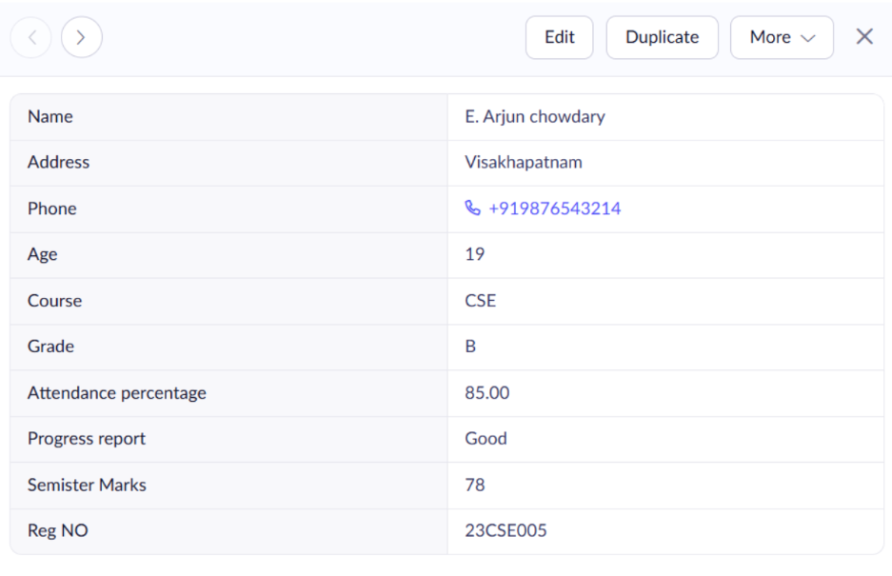
Figure 3: Individual Student Record

